Spring boot project

Starter -🡪 web starter

Starter -🡪 jpa starter

Dependency -🡪 mysql

Starter 🡪devtool (whenever we do any changes it automatically refresh the application)

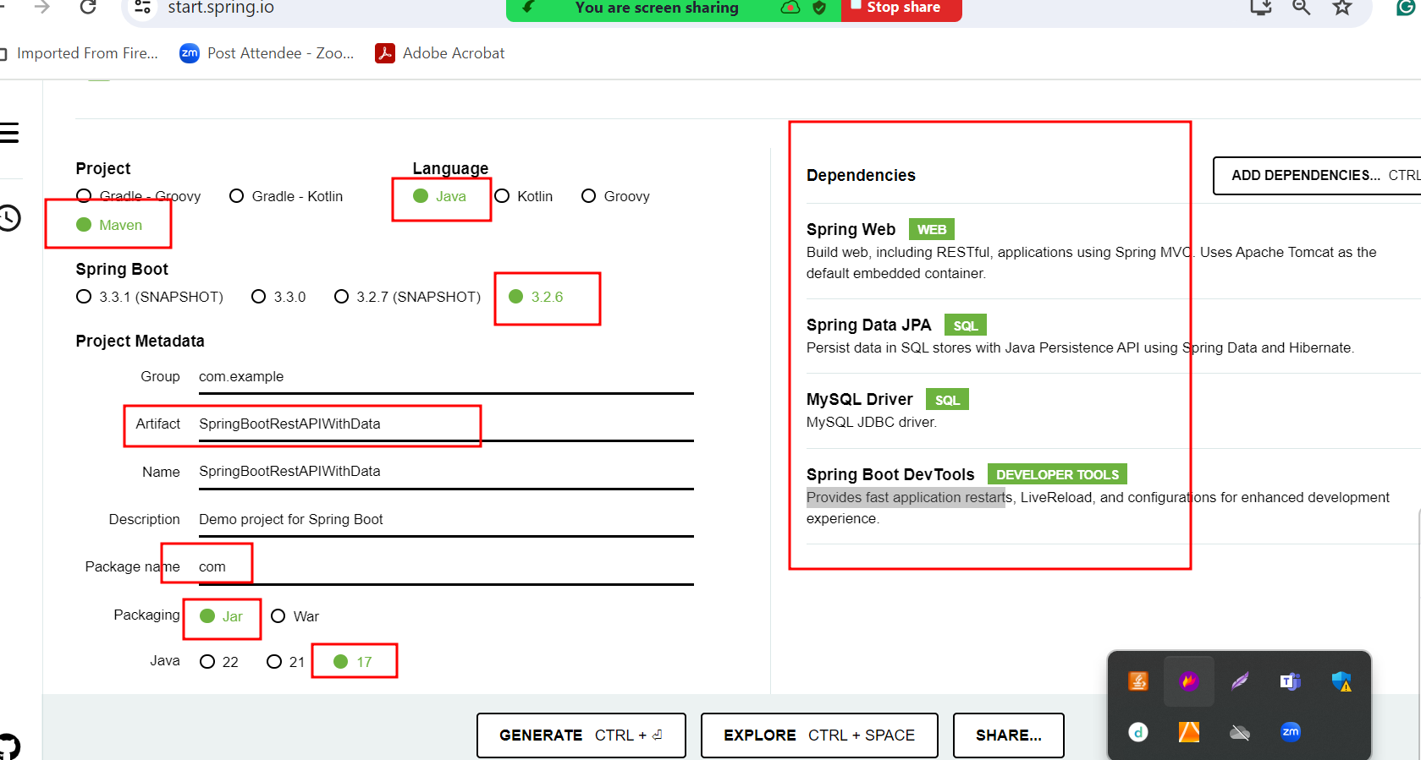

product table --🡪 PID(PK), pname , price etc

100 TV 56000

101 Computer 45000

create table product(pid int primary key,pname varchar(25), price float);

orders -🡪oid(PK), orderdateandtime, pid(FK)

1, 18/06/2024 8:54,100

2, 18/06/2024 8:55,100

3, 18/06/2024 8:56,101

Create table orders(oid int primary key auto_increment, orderdate datetime, pid int, foreign key(pid) references product(pid));